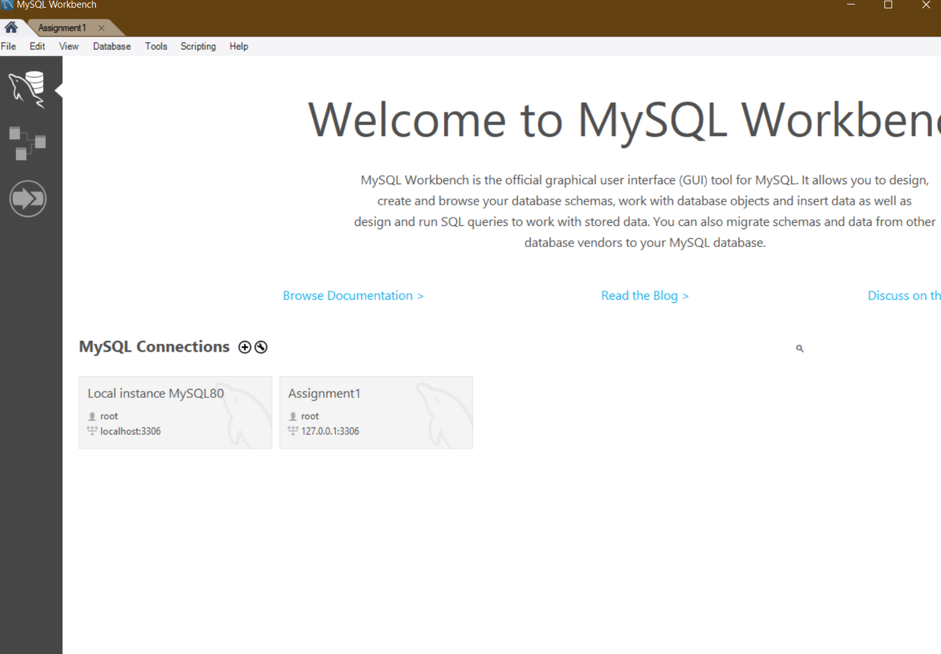

1. Assignment1 has been added into connection

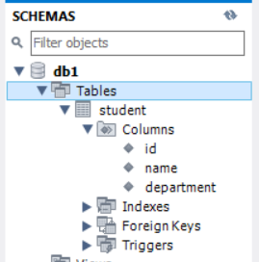

1. New schema(db1) has been created, and table with necessaries information has been added

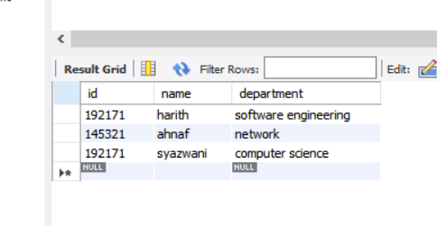

1. Have added some records in the table

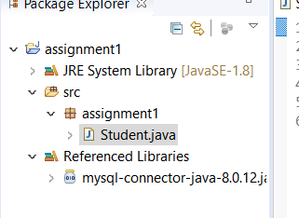

1. Java project has been created; MySQL connector has been added; package file has been created and class named ‘student’ has been created under src folder